Name: __________________________

End of Module Study Guide- Module 2

- Label the parts of the equation.

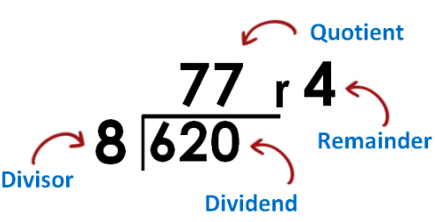

- Divide.

12,000 ÷ 300 | 560,000 ÷ 700
28,000 ÷ 40 | 810,000 ÷ 9,000

- Estimate the quotient for the following problems.

2,659 ÷ 28  ≈ _________ ÷ _________  = _________ | 2,525 ÷ 64  ≈ _________ ÷ _________  = _________
8,515 ÷ 89  ≈ _________ ÷ _________  = _________ | 4,945 ÷ 93  ≈ _________ ÷ _________  = _________
- Why is it helpful to estimate the quotient when solving a long division problem using the standard algorithm?

- Divide using the standard algorithm and show remainders. Multiply to check your answers.

71 ÷ 50 | 643 ÷ 80
553 ÷ 23 | 6,144 ÷ 35

- Divide.

- 6.4 ÷ 8 = _________________ b. 18.6 ÷. 20 = _____________________

- Estimate the quotients.

  - 3.24 ÷ 82 ≈

  - 361.2 ÷ 61 ≈

- Divide and multiply to check. There should be no remainders!

36.14 ÷ 13 | 6.89 ÷ 13
30.09 ÷ 59 | 300.9 ÷ 59

